
Final Individual Project Report

Georgoulis Ilias

Topic:

Identifying Pulsars. You will use the HTRU2 dataset containing Pulsar candidates collected during the High Time Resolution Universe Survey to identify Pulsars between other stars.

Approaches list :

The train dataset contains 12643 examples of stars, of which only 1166 are Pulsars, and a test dataset contains 5255 stars in total, and only 473 Pulsars.

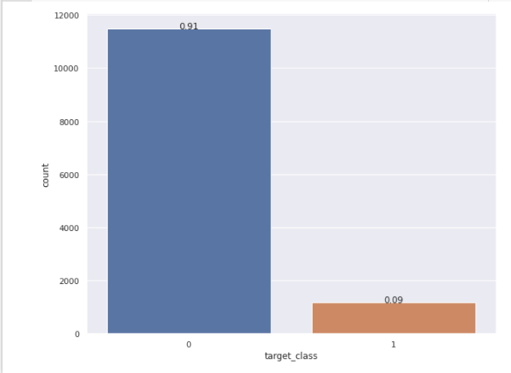
Image 1: Class destribution

The heavily unequal destribution will propably leed to training problems and can make models prone to identifying only the dominant class.

In this report I will present some of the approaches I tried to get the best possible confusion matrix. Here is the list of the presented approaches:

1)Plain ANN constraction and optimisation

2)Autoencoder

3) Multy headed ANN model

4)Augumentation methods(over-under sampling and SMOTE methods)

NaN values:

The first think I thought I had to do was to deal with NaN values as its something thas very common on datasets. Doing a search with SNS I found out that it doesnt contain any as it can be seen on image 2.
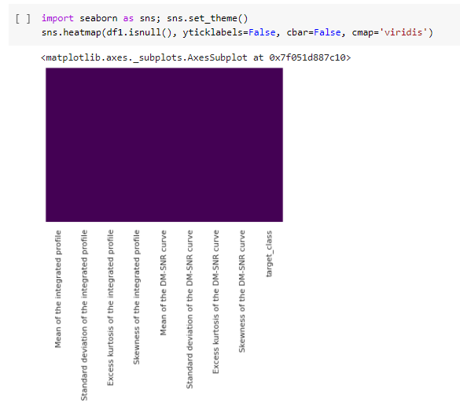
Image 2: The NaN values sns map appears blanc meanin there are no NaN values. In other case different collor lines would appear for missing values.

ANN:

Data scalling:

The wide range of train instances values made it essential to use a scalling method.

I tried MinMaxScaler ,MaxAbsScaler,StandardScaler ,RobustScaler
Normalizer,QuantileTransformer,PowerTransformer.

All of them improved the results and the training time but had very similar results. The best results came from StandarScaler and MaxAbsScaler.

I decided to use MaxAbsScaler as it did slightly better. MaxAbsScaler is similar to MinMaxScaler except that the values are mapped in the range [0, 1]. On positive only data, both scalers behave similarly.

Note: All the scalers were tested on the same model which was not optimised to fit each one of them.

The Model:

Starting with a pretty heavy model in terms of trainable parameters and having obvious overfitting problems the optimisation of the hyperparameters the different model stractures and finally a try to reduce as much as I could the trainable parameters I came up with the model that is presentet below.

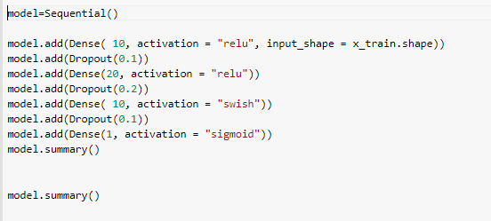
Image 3: Model stracture

Table 1: Models charachteristics

model :
Activation | Relu,swish,sigmoid
Optimiser | Adam
Batch size | 1024
early_stopping | patience =20, restore_best_weights = True,monitor='val_loss'
epochs | 477
loss | BinaryCrossentropy

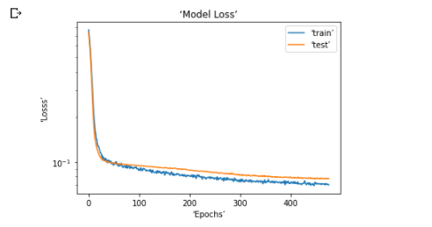
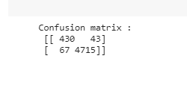
Image 4: Models learning curve and confusion matrix

Comments:
Once again the compination of relu and swish activation functions had great results on dealing with overfiting. Relu gives only possitive and zero values, swish in the other hand gives also negative values near 0 as it can be seen below. Using swish only in the last layer, has improved most of my models during this semester though I dont have a clear explanation why.In my mind this compination is a much softer elu.

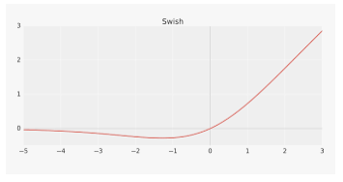
The model did great for its simplicity as it predicted 90% of the pulsars and 98.6% of the rest stars correct.

2)Autoencoder

The second approach that I tried to solve the problem with, was with the use of an autoencoder. The idea was to build an autoencoder trained to recreate the data of the dominant class. Having this knowledge and by giving for prediction the data of the test set which are a mix of both the classes, the error of the pulsars stars whould be signifinatly higher and by finding the right error threshold I could classify them.

This approach was by far the most time consuming for me as it was the main one I wanted to try. Though I couldn't get the results I expected even after countless different model structures I tried.

The Model:

First of all I grouped the train data in two different data sets seperated by their class. The train set consisted of 10329 instances.

After the training I calculated the mean loss for each label to find the threshold for the classification.

I show one of the last models I tried(in some point I got slightly better results ).

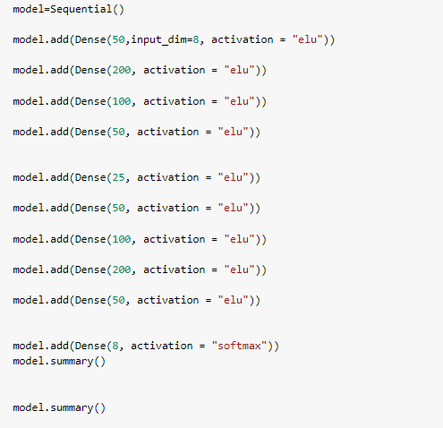
Image 5: Model2 structure

Table 1: Model2 charachteristics

model2 :
Activation | elu,softmax
Optimiser | Adam
Batch size | 508
early_stopping | patience =30, restore_best_weights = True,monitor='val_loss'
epochs | 355
loss | mse

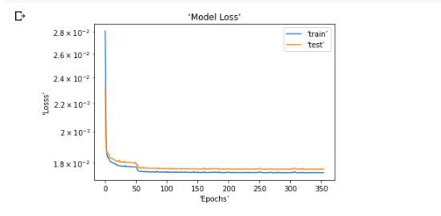
Image 6: Models learning curve and confusion matrix

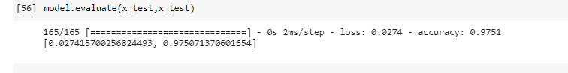
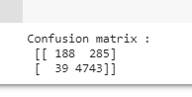

Image 7: Model evaluation and confusion matrix

Comments:

The models were pretty effiecient on recreating the given data as can be seen on Image6 but wasnt good for the classification task. The best results I got for pulsars limited at about 300 predictions. The result for the other stars were signifinantly better. As I saw by inspecting pulsar loss values many of them were recreated as well as the other stars so they couldnt classified right. The best results for pulsars came when the range of loss was bigger in some models of different stractures than the presented (exp.0-1000) but in this case the wrong stars also increased. Finally I thought that maybe a compination of two autoencoders for each class could solve the problem(probably compined with some augumentation for the puslar stars data).

3)Double headed ANN model

Having seen differences by the way I treated the data before the training I tried to make a double headed model thats more diverse than single input one, to see how will it perform on this problem. The first input's train data have been scaled using MaxAbsScaler. For
the other one I used PCA clustering. I used similar stractures with the ANN above. The autonomus stractures where then compined at some point as its shown on Image8.
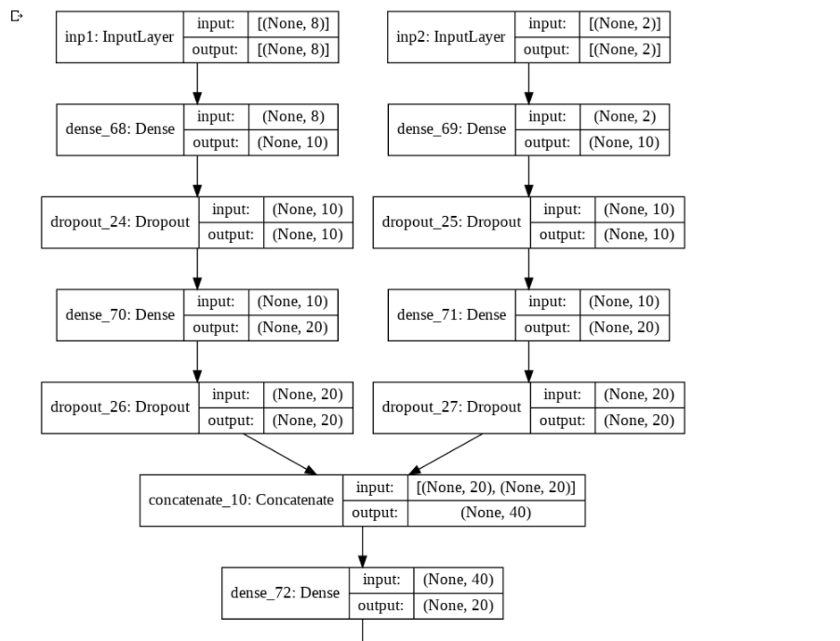
Image8: Part of double headed model's stracture

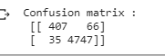
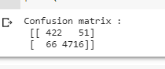

Image9: Confusion matrices for different rounding thresholds for the predictions(0.3,0.4).

Comments:

As shown by the images above the value over that the models predictions were essential for the results. 0.3 did better for common stars and 0.4 for pulsars. These values came by the mean prediction for its category on the validation set (something I have used again in previous models).
Something that could be done to improve this approach could be to use a multy headed model(for more diversity) instead of just a double headed.

Note: I have used the same stractures and hyperparameters for this models as ANN model so I didnt made a detailed description about them here again.

4)Augumentation methods

Due to the imbalance of the dataset on possible solution I thought to try balancing the data with augumentation methods such as random oversampling(randomly duplicate examples in the minority class )undersampling (randomly delete examples in the majority class. ) and SMOTE. Both oversampling and undersampling were not that effective and I wont present them here. SMOTE though gave the best results of all methods.SMOTE works by utilizing a k-nearest neighbor algorithm to create synthetic data. SMOTE first start by choosing random data from the minority class, then k-nearest neighbors from the data are set. Synthetic data would then made between the random data and the randomly selected k-nearest neighbor.

The role of scaling played a more significant role in this case as different scalers gave pretty different results.
The scaler that worked best in this case was StandarScaler.

The best SMOTE hyperparameters after the optimisation can be seen in the following Image.
Image10: SMOTE hyperparameters.

The models charachteristics can be seen in the next image.
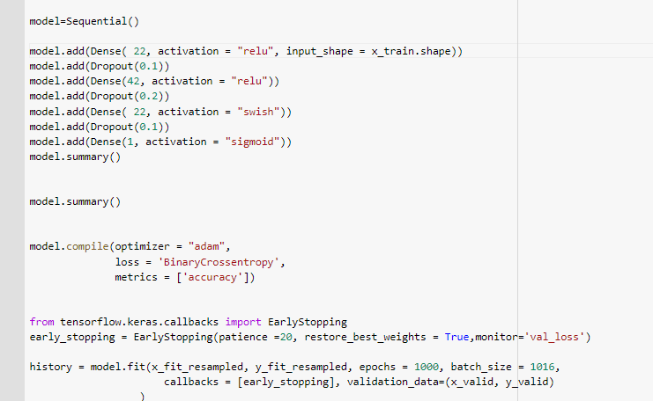
Image11: Model stracture

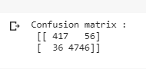
Image12: The models confusion matrix.

Comments:

The SMOTE augumentation method results were the best of all other models. SMOTE proved succesful on dealing with the inbalance of the dataset. The model achieved 87% accuracy on pulsar stars and 99.2% for the other stars with only 92 wrong prediction on the test set.

